# ETI’s ETIM Instruction 7.0 BMECad version 4.0

## General

* ETIM is available on open server
* Validated it according to ETIM BMECad certification tool, ready to use
* Version ETIM: 7.0
* Version BMECad: 4.0

## Available data:

* In contains basic EC (ETIM class), EV (ETIM value) and EF (ETIM feature) for ETI products
* This BMECad version 4.0 includes listed attachements:
  + Instruction manuals
  + Technical data catalogue
  + 3D model (stp file)
  + EU declaration
  + Dimension drawing
  + Photo

## User instructions:

Step 1: Visit webpage (server) bellow:

<https://files.eti.si/BMECad/>

Step 2: Choose from available formats and download

* + Xml (you need xml editor)
  + xlsx (excel) format.

Step 3: Basic ETIM data (EC, EF, EV) are available for use or implementation into your platform (ERP, WMS)

Step 4: Additional data (listed attachments) are integrated as links. To access them please join MIME ROOT (picture 1) with MIME SOURCE (picture 2) to generate proper link for attachment download.

MIME ROOT: Is always the same ( <https://files.eti.si/> ).

MIME SOURCE: Differs for different ETI codes and attachments.

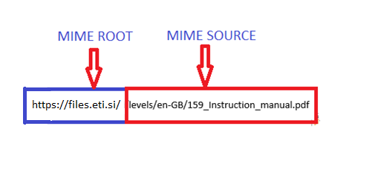

Picture 1: MIME ROOT example from XML editor

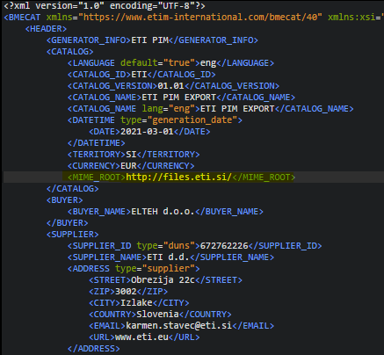

Picture 2: MIME SOURCE example from XML editor

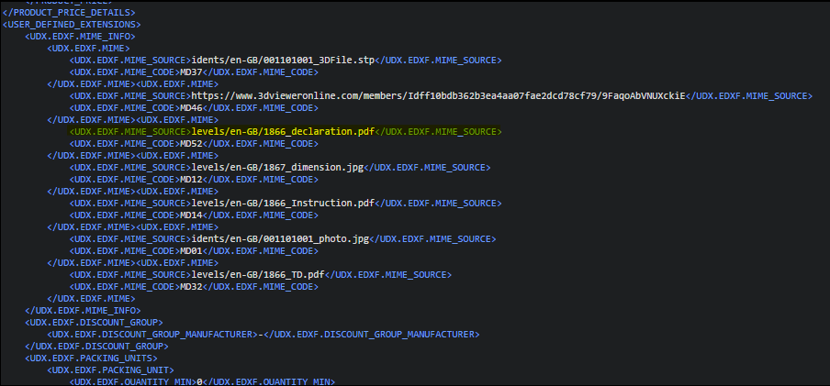

Example of generating proper link for download

Example Item code: 002173227

* Listed attachements:
  + Instruction manuals

https://files.eti.si/levels/en-GB/159_Instruction_manual.pdf

* + Technical data catalogue

https://files.eti.si/levels/en-GB/152_TD.pdf

* + 3D model (stp file)

https://files.eti.si/levels/en-GB/161_3DFile.stp

* + EU declaration

https://files.eti.si/levels/en-GB/159_declaration.pdf

* + Dimension drawing

http://files.eti.si/levels/en-GB/159_dimension.jpg

* + Photo

https://files.eti.si/idents/en-GB/002173227_photo.jpg